1. Connect to server

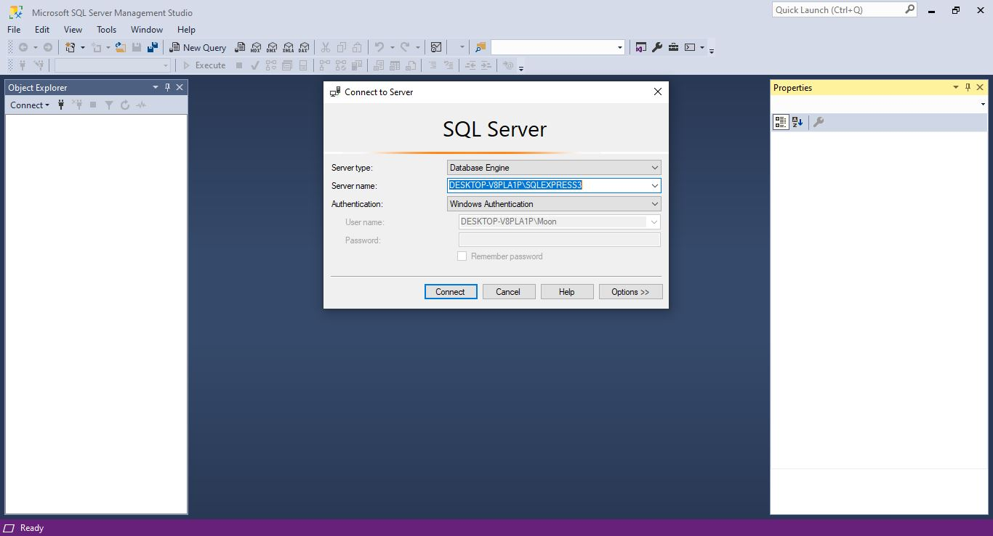

1. Uploaded AdventureWorksDW2017 Database

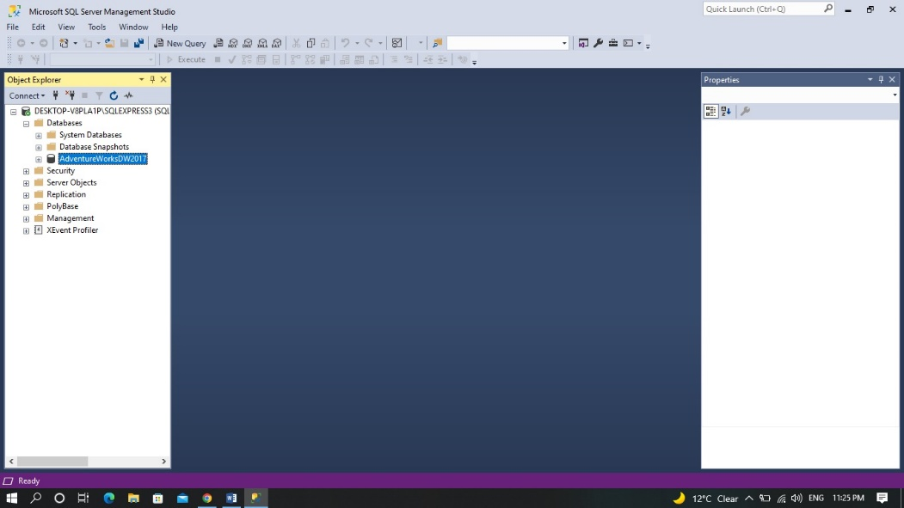

1. Check the data for one or two table (dbo.DimEmployee)

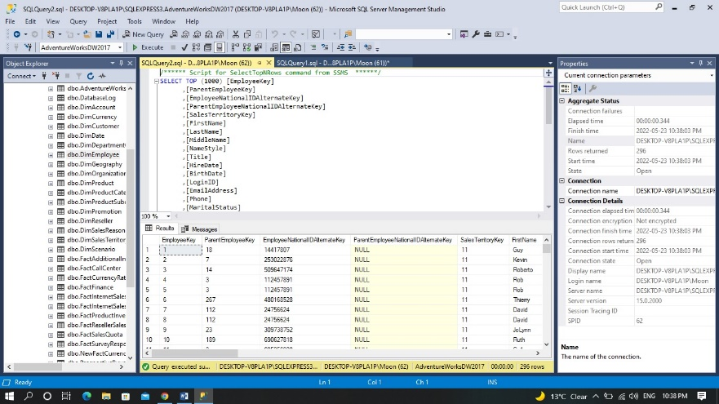

1. Extract Sample Currency Data_najmun columns

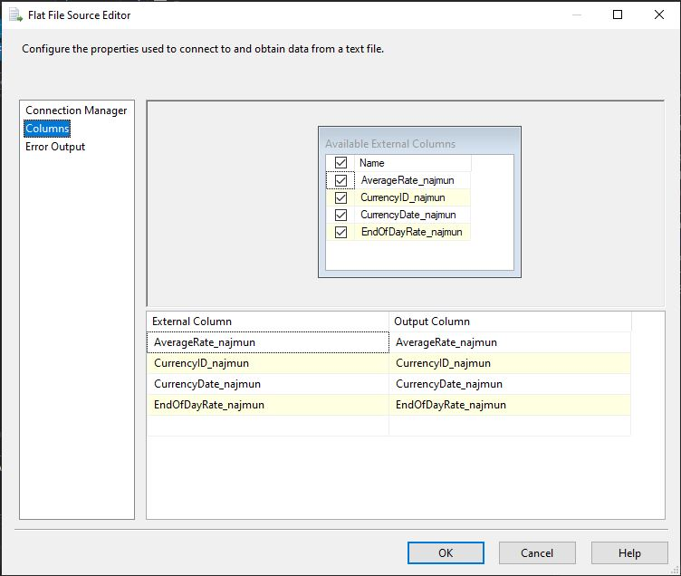

1. (Visual Studio) Data Flow

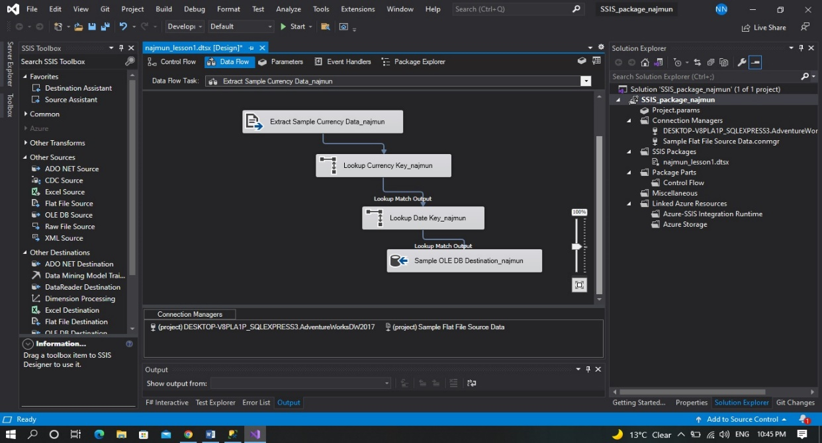

1. Lookup Currency Key_najmun Columns

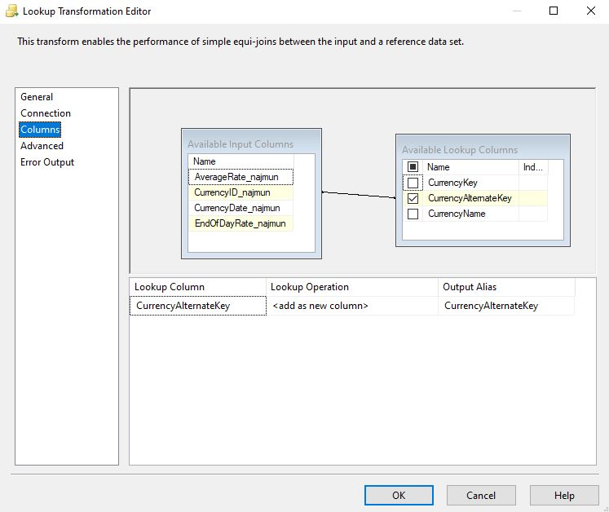

1. Lookup Date Key_najmun columns

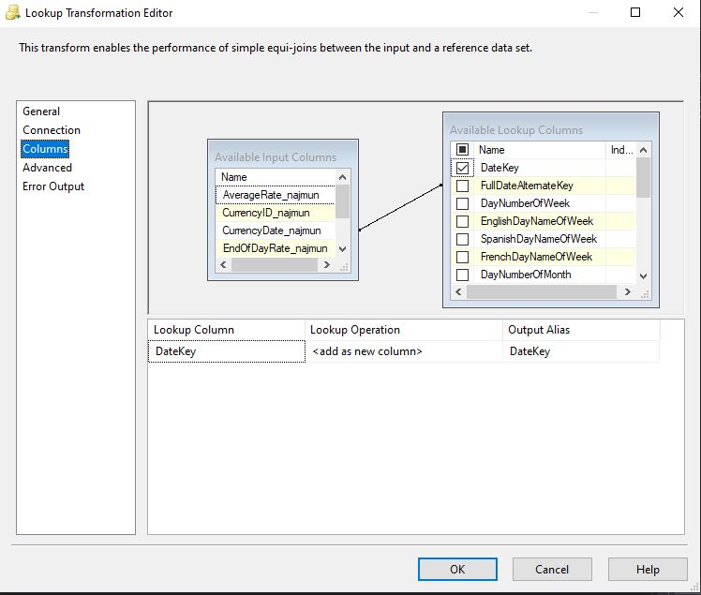

1. Sample OLE DB Destination_najmun

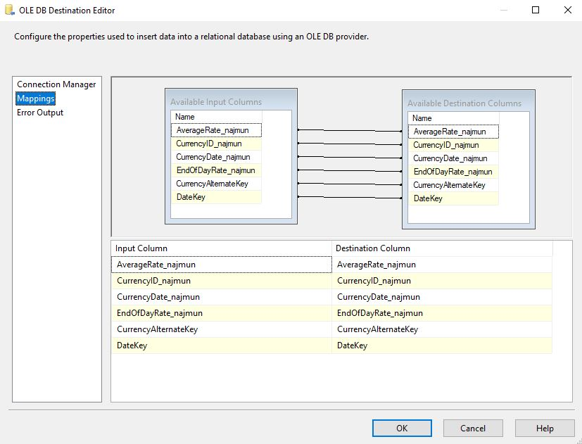

9. Debug start. The package runs, resulting in 1,096 rows successfully added into the NewFactCurrencyRate fact table in AdventureWorksDW2017

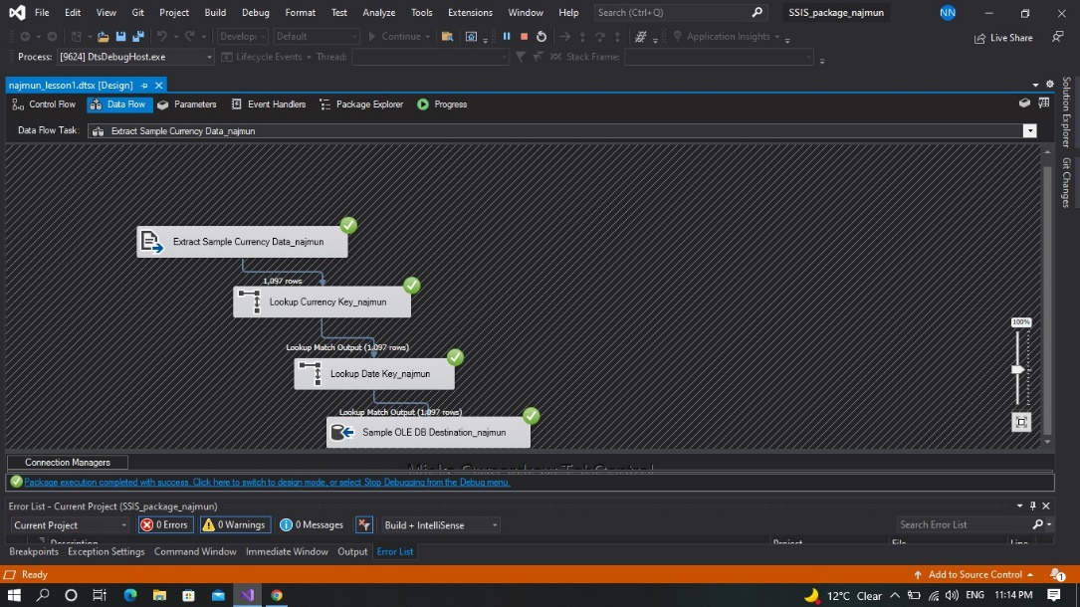

1. Launch Microsoft Management tools and display top 1000 rows of the new currency fact table

